FOR IMMEDIATE RELEASE: CONTACT: Rebecca O’Day, roday@qats.com

Ultra-Low Temperature Freezers for Vaccine and Laboratory Cold Storage Introduced by ATS
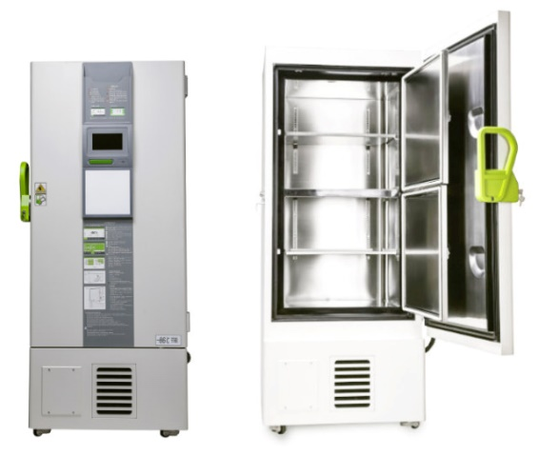
Norwood, MA, January 8, 2021 – The Vostok series of ultra-low temperature freezers from Advanced Thermal Solutions, Inc., ATS, can continuously store biological materials, including vaccines at temperatures as low as -86°C (-123°F) with +/- 0.1°C accuracy.

Both freestanding and portable Vostok freezers are available to meet a variety of medical needs. They can safely maintain large volumes of COVID-19 vaccines within their needed low-temperature requirements, as these treatments deploy locally across the world.

ATS’ Vostok M80 cabinet freezers are ideal for biological storage, including vaccines, viruses, germs, blood plasma, skin, bone marrow, sperm, and other biological, pelagic, and special test products. A range of sizes and features are available with storage capacities from 11.9 to 29.59 cubic feet (228-838 L). Easily accessed racks can hold 19,200-60,000 2ml vial samples or 192-600 2-inch boxes.

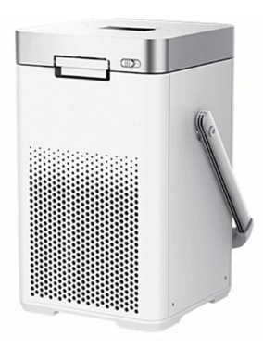
The castor-equipped, stainless steel freezers are easily set up in any ambient (10-32°C, 50-90°F) location, and run at just 50-55 dB volume. With their optimized evaporator design and state-of-the-art compressors, all Vostok freezers can be set to precise cooling temperatures, as low as -86°C. In the event of a power failure, the freezers have a 72-hour backup system with alarm. Chart recorders and data loggers can be added via USB connection to monitor, record, and analyze environmental parameters. An optional CO₂ backup system maintains required ultra-low temperatures in the event of a power failure.

The portable Vostok PortM80 freezer has a compact, lightweight design to facilitate transport of vaccines while maintaining temperatures down to -86°C. Its cooling technology is adapted to master vibration and transportation bumps. Environmentally safe helium is the refrigerant, providing long-term, high-reliability performance.

Vostok ultra-low temperature freezers are ideal for hospitals, vaccination sites, local clinics, blood banks, epidemic prevention, and response services, research institutes, biomedical and chemical industries, and marine fishing industries.

All Vostok freezers are available from Advanced Thermal Solutions and can be ordered online. More information is available on Qats.com, or by calling (781-769-2800) or emailing the company at ats-hq@qats.com.

###
About Advanced Thermal Solutions
Advanced Thermal Solutions, Inc. (ATS) has been in business for more than 25 years as a leading-edge engineering and manufacturing company focused on the thermal management of electronics. Founded in 1989 as a consulting company, ATS has evolved into a complete airflow filtration and thermal solutions provider. ATS provides a family of ultra-low temperature freezers and air cleansers for room-level air filtration to remove viruses, including COVID-19. ATS is also world-renowned for its portfolio of more than 5,000 high- and ultra-performance heat sinks. It provides industry-leading liquid cooling solutions, the broadest off-the-shelf line of heat pipes, expert consulting and design services, research-quality test equipment, and leading edge R&D. ATS has established its own manufacturing center in the U.S. and developed strategic partnerships with Asian manufacturers to provide its global customers with complete thermal solutions ready to tackle the industry’s toughest challenges. ATS is headquartered in Norwood, MA, about 30 minutes south of Boston. Learn more at https://www.qats.com/

